**Test case ID 1.2**

**Title: Color pallet is displayed correctly after first choosing one of colors (first installing app)**

**Environment: Sunny Bunnies Coloring Book**

**Version: 3.0**

**Prerequisite: Installed app, no previously painted pictures, opened picture**

**Reproduction Steps:**

**1. Choose color**

**2. Switch colors**

**Expected result: Color pallet is displayed correctly. Colors switch.**

**Final conditions: Possibility to switch other color.**

**Test data: -**

**Author: Yana Nazarava,** [**yankaya15@gmail.com**](mailto:yankaya15@gmail.com)

**Bug Report ID 1.2 IPHONE 13, IOS 16.5**

**Title: Color palette disappears after the first selection of one of colors**

**Severity: Major**

**Environment: IPHONE 13, IOS 16.5**

**Description: Color palette disappears. Colors don’t switch.**

**Color palette disappears when you select one of colors - and you can no longer switch colors. This happens after the first installation of app. You can switch colors only after that you finish one automatically-opened picture.**

**Prerequisite: first installed app, no previously painted pictures, opened picture**

**Reproduction Steps:**

**1. Choose color**

**2. Switch color**

**Current Result: Color palette disappears. Colors don’t switch.**

**Expected result: Color palette is displayed correctly. The colors are switched.**

**Attachments:**

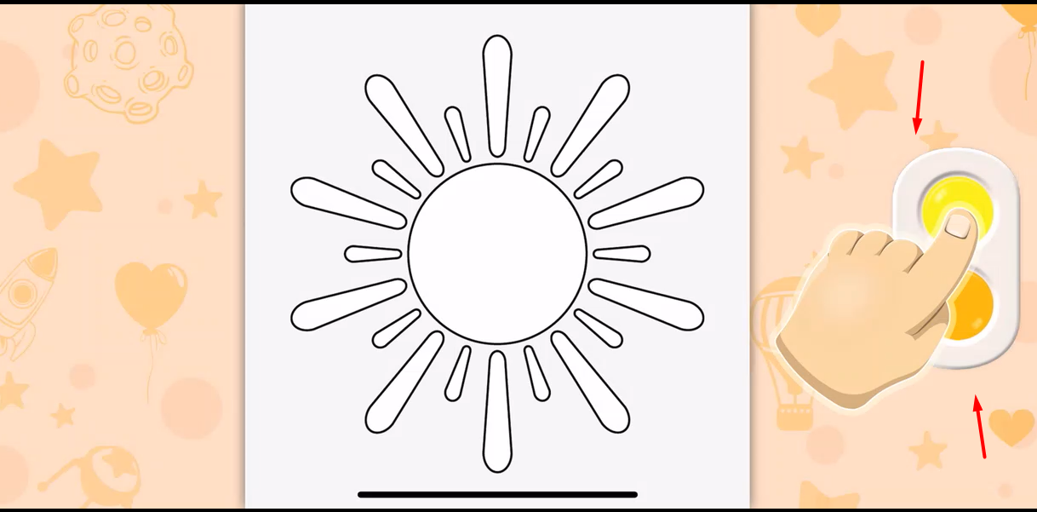click

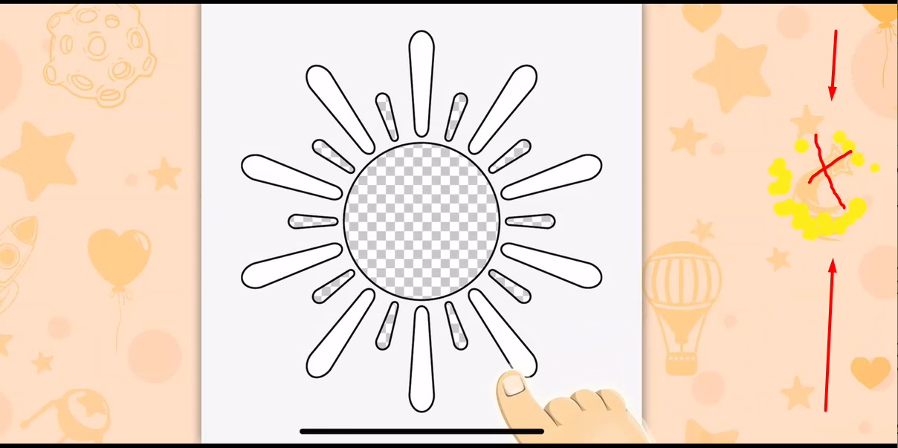color palette disappears